**Front page**

The provided HTML code is a basic webpage template for an SmartWatch product website known as AShop. Here's a summary of the key components and functionality:

1. **Document Structure**:

- The code defines an HTML5 document structure with a typical `<head>` and `<body>` section.

- It includes a JavaScript section for interaction and functionality.

2. **Header Section**:

- The website's title, “AShop" is defined in the `<title>` tag.

- A favicon is set for the website.

- External CSS styles are linked using the `<link>` tag.

- The Boxicons library is imported for additional icons.

3. **Body Content**:

- The webpage content is organized into several sections, including the homepage, product types, reviews, our store, and a footer.

4. **Homepage Section**:

- The homepage introduces the website as a destination for electronic products.

- A call-to-action button "Shop Now" is provided, which scrolls down to the product types section when clicked.

5. **Product Types Section**:

- This section displays various product categories, such as Apple Watches , Samsung Watches etc., each with an image and a link to an individual product page.

- There are some HTML syntax issues in this section, including missing closing `<h3>` tags and an incorrect inline CSS property.

7. **Our Store Section**:

- This section displays images of the store.

8. **Footer Section**:

- The footer provides links to various social media platforms.

9. **JavaScript Functionality**:

- JavaScript is used to trigger an alert when the page loads.

- There are functions to handle "Shop Now" and "Login" button clicks.

- Event listeners are added to the "Shop Now" and "Login" buttons.

- Added light / dark switch to Website

10. **Issues and Considerations**:

- There are some HTML syntax issues and missing CSS selectors that need to be addressed.

- The image sources should point to valid image files.

- The links in the footer should point to actual social media profiles.

- Individual HTML pages for the product categories (e.g., "product.html") need to be created to provide content for those sections.

Overall, the code provides a basic structure for an Watch retail website with placeholders for content, styling, and interactivity. It would require additional development and content to make it a functional website.

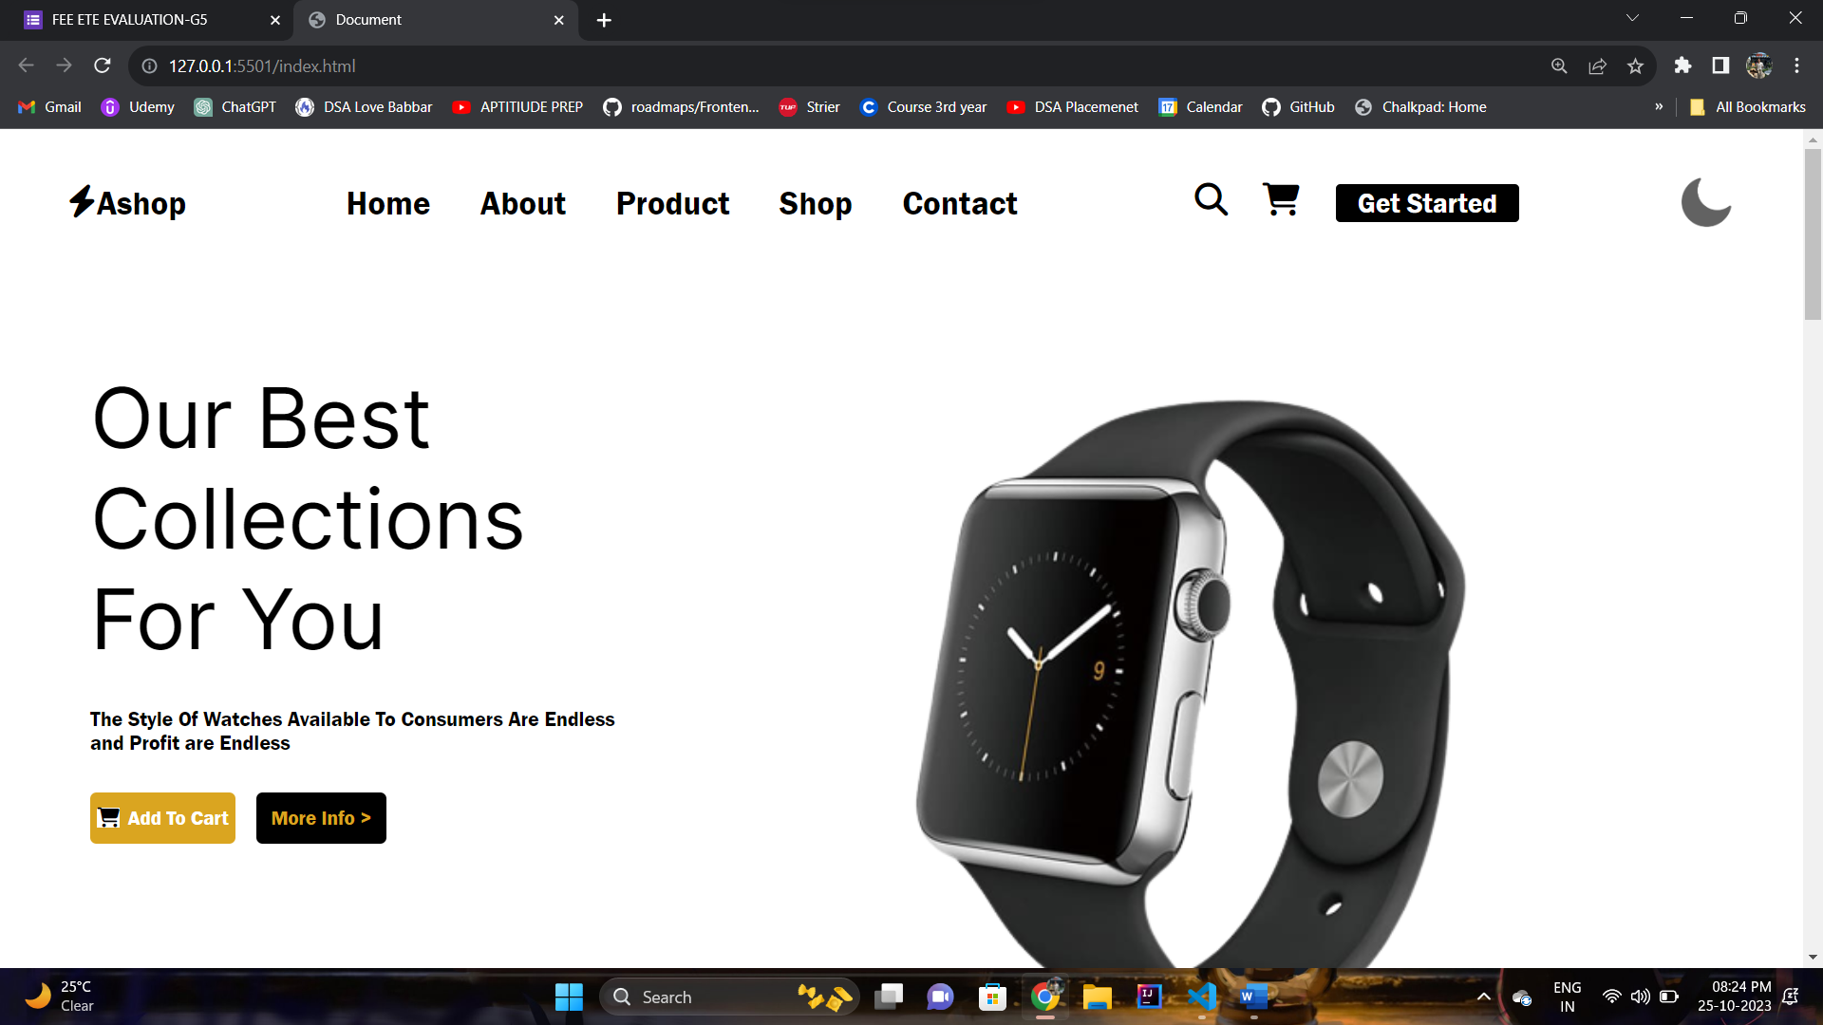

**Sub Category Page**

1. **Document Structure**:

- The document starts with the typical HTML structure, including the `<head>` and `<body>` sections.

2. **Header Section**:

- The page title is set as "Products."

- A favicon is specified using the `<link>` tag.

- The header includes a logo that links to a "Category.html" page.

- There's a logo containing an icon (utensils) and the product category name "Noise SmartWatch."

- A menu icon is present (hamburger icon) for potential navigation options.

- The navigation bar includes links to "Home," "Brands," "Order," and "Socials."

3. **Home Section** (ID: "home"):

- This section introduces the product category "Apple Watch."

- A brief description encourages users to shop for watches.

- A "Shop Now" button is provided with a link to the "order" section.

4. **Brands Section** (ID: "brands"):

- This section presents a list of available brands for air conditioners.

- The heading "Brands Available" is provided.

- Each brand is displayed in a box with an image and a link to a specific page for that brand.

- The brands showcased include NOISE , BOAT , APPLE .

5. **Styling**:

- External CSS styles are linked using the `<link>` tag with the reference to "product.css." The styling for this page is likely defined in that stylesheet.

6. **Links and URLs**:

- Links are set for the brand images, allowing users to navigate to specific brand pages for air conditioners.

- The "Shop Now" button links to the "order" section within the same page, likely for product ordering.

This HTML code provides a basic structure for an "Product" product category webpage. Users can navigate to specific brand pages to explore SmartWatch products. The code acts as a template and can be further developed to include detailed product information, pricing, and other relevant content.

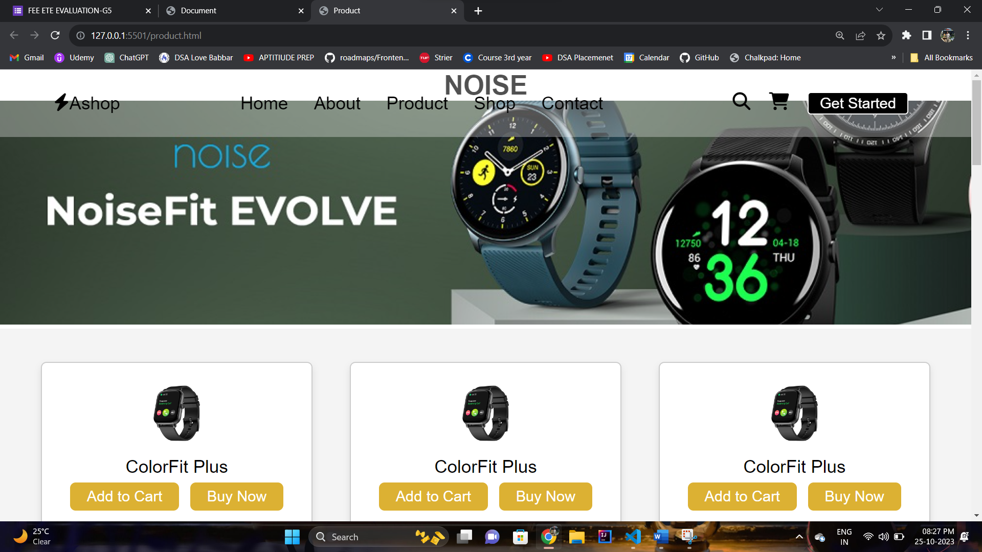

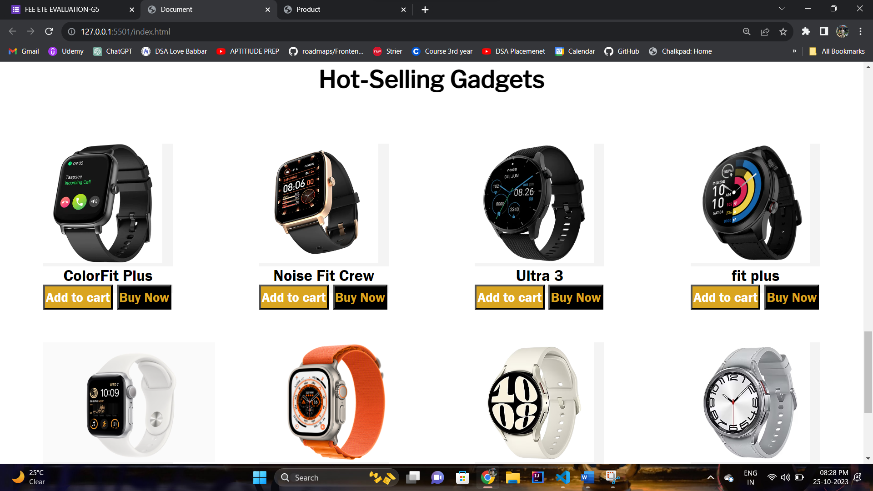

**Login and Sign In Page**

**Synopsis of the HTML Code:**

The provided HTML code represents a webpage for a login page on the "AShop" website. Here's a summary of the code's structure and content:

1. **Document Structure**:

- The code starts with the typical HTML structure, including the `<head>` and `<body>` sections.

2. **Header Section**:

- The page title is set as "AShop."

- A favicon is specified using the `<link>` tag.

- External CSS styles are linked using the `<link>` tag with a reference to "Signup.css."

- The header includes the website logo and a navigation bar with links to "Home," "Brands," "Order," and "Socials."

3. **Login Section**:

- This section is dedicated to the login functionality.

- It features a "Login" heading.

- A form is provided with the action attribute set to "Product.html," suggesting a redirection to the category page upon submission.

4. **Form Elements**:

- The form contains input fields for a username and password.

- Each input field is accompanied by an icon from the Boxicons library for the user and lock.

- A "Remember me" checkbox is included.

- There's also a link to "Forgot Password ?" that may lead to a password recovery page.

- A "Login" button is provided for submitting the form.

5. **Styling and Icons**:

- The page style is likely defined in the external "login.css" stylesheet.

- Icons from the Boxicons library are used to enhance the visual design.

This HTML code serves as a foundation for a login page on the "AShop" website. Users can enter their login credentials to access their accounts, and there is an option for password recovery and registration. The code can be further developed to handle actual user authentication and include more user-friendly features.

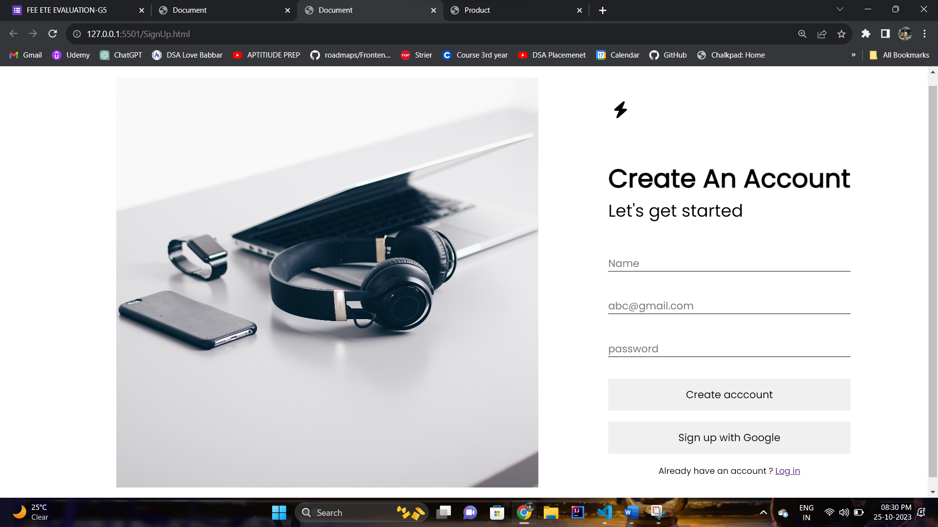

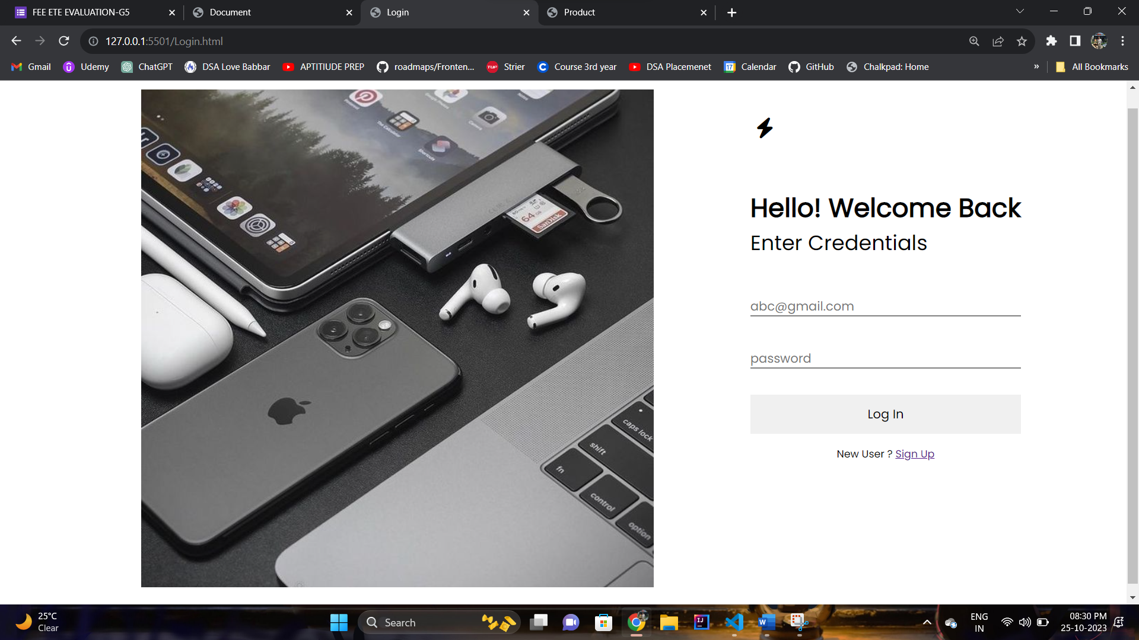

**Contact Us**

1. **Document Structure**:

- The document starts with the usual HTML structure, including the `<head>` and `<body>` sections.

2. **Header Section**:

- The page title is set as "AShop."

- A favicon is specified using the `<link>` tag.

- The header includes a logo image that links to a "ContactUs.html" page. It also contains a navigation bar with links to "Home," "Product Types," "Our Store," and an "Order" section.

3. **Contact Section**:

- This section is dedicated to allowing users to contact the AShop Team.

4. **Content**:

- A large image of the AShop logo is displayed.

- A short description encourages users to reach out for assistance.

5. **Styling**:

- Some inline CSS is used to style the icons and adjust their size.

6. **Links and URLs**:

- Links to various HTML pages and external resources (e.g., images, stylesheets) are specified. However, some links are left empty (`<a href="">`), which should be updated to point to the correct URLs.

8. **Synopsis**:

- The HTML code serves as a foundation for a contact page on the AShop.

- It provides various contact options for users, encouraging them to provide feedback, chat with support, visit the office, or call for assistance.

- To make this page fully functional, the empty links need to be updated with appropriate URLs, and the associated HTML pages should be created for feedback forms and other content.

